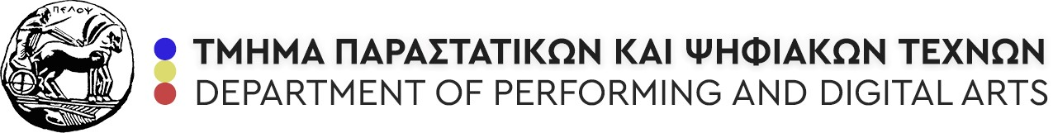

TYRONE GRIMA, Senior Lecturer II, MALTA COLLEGE OF ARTS SCIENCE AND TECHNOLOGY
tyronegrima@gmail.com

TEACHING MOBILITY ERASMUS+

SCHEDULE

MONDAY, DECEMBER 11, 3.00-6.00 PM
COURSE TITLE: CONTEMPORARY AMERICAN THEATRE AND PERFORMANCE [TAUGHT EXCLUSIVELY IN ENGLISH]
Lecturer: MARIA VARSAMOPOULOU
Email : m.varsamopoulou@uop.gr
CENTRAL BUILDING, GROUND FLOOR
University of the Peloponnese, Department of Theater Studies - Google Maps
Subject: American Queer Theatre

TUESDAY, DECEMBER 12, 9.00 AM-12.00 PM
COURSE TITLE: SOCIAL APPLICATIONS OF PERFORMANCE I
Lecturer: STELLA PLATSKOU
Email : s.platskou@uop.gr
CENTRAL BUILDING, 1ST FLOOR, AULA “LEDA TASSOPOULOU”
University of the Peloponnese, Department of Theater Studies - Google Maps
Subject: Augusto Boal and the Theatre of the Oppressed

THURSDAY, DECEMBER 14, 7-8.30 PM
LECTURE: QUEER THEATRE - Open to all undergraduate students
PINAKOTHIKI BUILDING, 1st FLOOR
Vasileos Konstantinou & Aggelou Terzaki - Google Maps

FRIDAY, DECEMBER 15, 10.00-12.00
COURSE TITLE: PERFORMANCE AND SPACE
Lecturers: ATHENA STOURNA and PABLO BERZAL CRUZ
CENTRAL BUILDING, GROUND FLOOR
University of the Peloponnese, Department of Theater Studies - Google Maps
Subject: Sacred Space - workshop

